
Sukkur Institute of Business Administration University
Department of Computer Science

Programming Fundamentals (C++)

BS – I (Computer Science - D)

Fall 2025

Instructor: Nisar Ahmed Siddiqui

LAB # 01

Submission Profile

Name: Abdul Wasio
CMS ID: 023 - 25 - 0007
Date: 07th September 2025
Receiving Authority: Sir Nisar Ahmed Siddiqui

PROGRAMMING FUNDAMENTALS
TABLE OF CONTENTS
03
Activity
06
Exercise 1
08
Exercise 2

09
Exercise 3

10
Exercise 4

10
Exercise 5
11
Exercise 6

Activity 1
Write a C++ program that prints/displays your name on the screen.
Program
#include<iostream>
using namespace std;
int main(){
cout<<"My First Name is Abdul"<<endl;
cout<<"My Middle Name is Wasio"<<endl;
cout<<"My Last Name is Shaikh"<<endl;
system("pause");
return 0;
}

Output
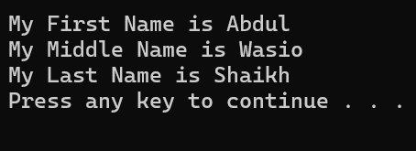

Activity 2
Write a C++ program that prints your details, like name, student ID, batch and the department, each on a separate line.
Program
#include <iostream>
using namespace std;
int main(){
cout<<"Name: Abdul Wasio Shaikh";
cout<<"\nF'Name: Abdul Hameed Shaikh";
cout<<"\nNumber: 03243051146";
cout<<"\nGender: M";
cout<<"\nAge: 18";
cout<<"\nEdu: Studying BSCS at SIBAU";
cout<<"\nSection: D";
cout<<"\nCMS ID: 023 - 25 - 0007\n";
system("pause");
return 0;
}
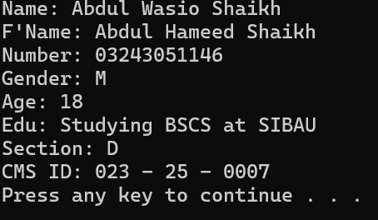
Output

Activity 3
Write a C++ program to print numbers from 1 to N (where N is the number of characters in your first name) on the same line with each pair of adjacent numbers separated by space in the following ways: Suppose your full name is Ahmad Mujtaba hence, your first name is Ahmad which contains five characters.
1 2 3 4 5.
Write a program to achieve the aforementioned task in following three ways.
a. Using one statement with one stream insertion operator.
b. Using N statements
c. Using one statement with N stream insertion operators.

Program
#include<iostream>
using namespace std;
int main(){
cout<<"My Middle Name is\"Wasio\"\n";
// As my name is Abdul Wasio so there is 5 lettes in my Middle name
cout<<"1\t"<<"2\t"<<"3\t"<<"4\t"<<"5\t\n";
system("pause");
return 0;
}
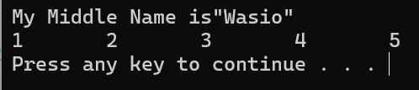
Output

